Lymphoedema help for my big brother by Sandra Bradburn
"In June 2020, during the worst health crisis of our lives I picked up the telephone to hear my big brother breakdown and cry.
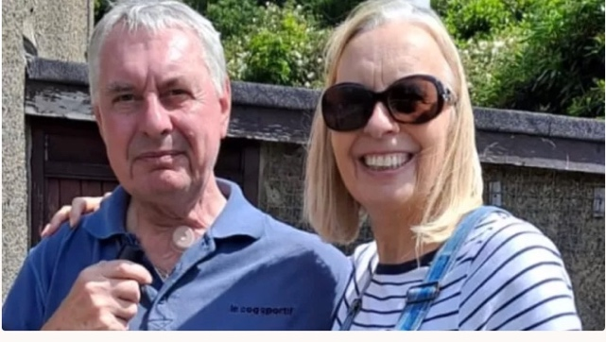

Brother and Sister, Steve and Sandra Bradburn
Sandra desperately wants to help her big brother Steve manage Lymphoedema at home and improve his quality of life
At only 58 years old, he had just been told that he had extensive cancer of his larynx (voice box) and lymph nodes in his neck and without surgery he may die within 3 months. If that was not bad enough, they then told him that even if he chose to have the significant life changing surgery it may be too risky to operate as he would not survive if exposed to covid. He still braved to ask, “how life changing?” The reply, “you will never speak again, you may not be able to eat or drink normally, you will have to breathe through a hole in your neck, you are likely to lose your teeth and your hair, and you may also lose the ability to raise your arm!”
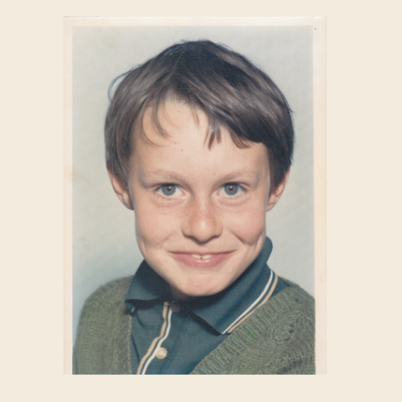
My independent, hard-working brother who had learnt from a very young age to cope with every challenge that was thrown at him, suddenly was at a complete loss, how could he decide…how could he go on… will he be given the opportunity to decide…. how can he be there to support those he loves? So many fears and it felt like such an impossible decision to make, the surgery could kill him, covid could kill him, but so could the cancer so eventually the decision was made and with love and support of family and friends he went for the operation in July 2020.

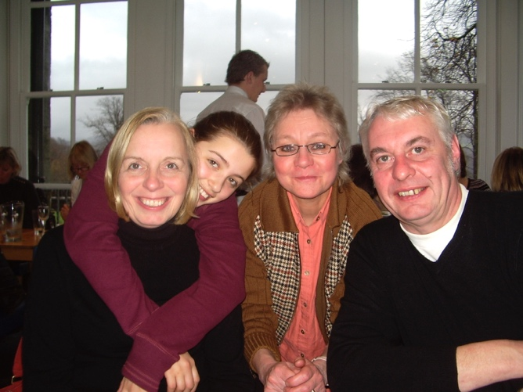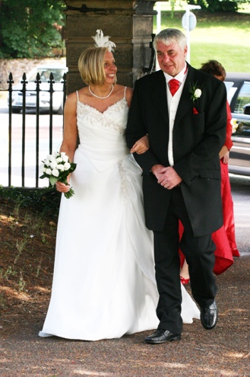
Steve with sister Sandra, Charlie, and Jan and giving his sister away
The surgery removed a considerable amount of his neck, including his voice box and lymph nodes and he then spent the next 4 weeks recovering in a covid secure room, with so much scary medical equipment and the terror of not being able to breathe or even vocalise his fears. However, he remained strong and could not wait to get back to his wife, Jan and his 2 dogs, Loki and Foxy.
He has had to learn how to live a different life. He cannot speak normally but has shocked all the clinicians by how quickly he has adapted to using an electrolarynx to speak with so he can be understood. Despite many setbacks he has been able to eat and drink again and is keeping his diabetes under control. After the initial fear he has now realised that he can breathe through his neck and is caring for it really well, as well as learning how to use the medical equipment that is required. He was determined to support himself and his family financially and has returned to work even doing a lot of the manual labour himself.
BUT the nightmare for him is LYMPHOEDEMA – a common complication caused by the removal of the lymph nodes where an excess of fluid collects in the tissues causing excessive swelling.

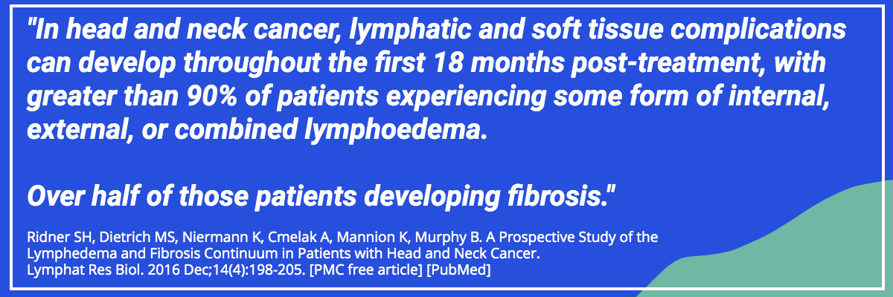

For Steve this swelling:
- Reduces the effectiveness of the electrolarynx making it difficult for his speech to be understood
- Presses onto his throat making swallowing really difficult and painful and so reducing how much he can eat and drink
- Reduces the size of the hole which he breathes through – can you even begin to imagine how scary this is?
- Reduces his movement in his shoulders and arms and causes significant pain when even doing the smallest of tasks

Lymphoedema cannot be cured but it can be very effectively managed!

How – by the use of DEEP OSCILLATION®

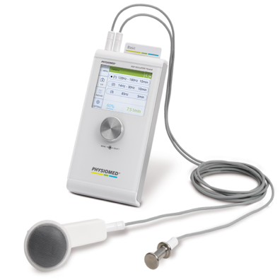

DEEP OSCILLATION® [1-25] is internationally patented electrostatic massage therapy – it is safe, gentle and effective and it has quickly become the treatment of choice in first line management of Lymphoedema
Steve was fortunate to have been loaned one of these units when he was first diagnosed, which Jan then used twice a day to massage the areas of lymphoedema making his life so much more bearable. Sadly, he has now had to return this to the lymphoedema clinic as there is only one machine available in the whole of the area Steve lives. He was then offered just one 20-minute session per week and the swelling; pain and complications listed above are becoming increasingly problematic. Now they have said that due to lack of resources and funding even this is to be stopped. He is scared and it is a horrendous situation to be in.
The DEEP OSCILLATION® plus attachments, which is purchased through a company called PhysioPod (https://www.physiopod.co.uk) costs £3,145.00
Steve has done so well and has been told by his lymphoedema nurse to try raising money to buy himself this as it is the only effective way to manage his lymphoedema, but as always Steve will not ask for help for himself, but I will, as he is my big brother who I love very much.
Throughout our lives, even as children, we have been involved in fundraising for various causes and now I ask for your help to see if we can make Steve’s new, very life changed life, a little more bearable.
Thank you"
Sandra Bradburn
Deep Oscillation References
- Atashkhoei S., Fakhari S. (2016): Management of Breast Cancer Related Lymphoedema. Crescent Journal of Medical and Biological Sciences 3 (4), 111-112.
- Brenke R. - Therapie des Lymphödems EHK 2021; 70: 138-144 DOI - 10.1055/a-1477-817
- Brenke R., Freund R., Strößenreuther RHK (2010): Adjuvant physical therapy for lymphedema and selected comorbidities of the musculoskeletal system. In: Földi M., Földi E. (Ed.): Textbook Lymphology. 7th ed., Elsevier GmbH, 508.
- Brenke R., Siems W. (1996): Adjuvant Therapy for Lymphedema. Lymphol 20, 25-29.
- Flemming D. (2016): The technique of deep oscillation. Lymph self-help, 22-23.
- Gasbarro V., Bartoletti R., Tsolaki E., Sileno S., Agnati M., Coen M., Conti M., Bertaccini C. (2006): Ruolo dell'oscillazione profonda (Hivamat® 200) nel trattamento fisico del linfedema degli arti. La medicina estetica 30 (4), 473-478. English title: The role of deep oscillation therapy (Hivamat® 200) in the physical treatment of the lymphoedema of the limbs.
- GDL (Society of German-speaking Lymphologists) u. DGL (German Society of Lymphology) (2017): AWMF-S2k Guideline "Diagnosis and Treatment of Lymphedema" (AWMF Reg. No. 058-001).
- Jahr S, Schoppe B, Reisshauer A. Effect of treatment with low-intensity and extremely low-frequency electrostatic fields (Deep Oscillation) on breast tissue and pain in patients with secondary breast lymphoedema. J Rehabil Med. 2008 Aug;40(8):645-50. doi: 10.2340/16501977-0225. PMID: 19020698.
- J of IMAB 2016 Jul-Sep;22(3):1248-1252 Improving the quality of life through effects of treatment with low intensity, extremely low frequency electrostatic field with DEEP OSCILLATION® in patients with breast cancer with secondary lymphedema to patients treated with standard lymph equipment. Atanas Petkov1 Corresponding Autor, Yana Kashilska2, Angel Uchikov1, Dean Batzelov3,
- Jui Chu Y. (2017): HIVAMAT 200. In: Jui Chu Y. (Ed.): What Can Physical Therapy Do After Breast Cancer Surgery. CARE, 187-188. German translation: What can physical therapy do after breast cancer surgery.
- Kraus R. (2014): Intensive lymphatic drainage through deep oscillation. LYMPH & Health 2, 6-8.
- Lipiska A., Opuchlik A. (2014): Fizycoterapia w onkologii. In: ?liwi?ski Z., Siero? A. (Ed.): Wielka Fizjoterapia. Elsevier GmbH, 289-294. English title: Physical Therapy in Oncology.
- Mortimer P., Levine G. (2019): Let's Talk Lymphoedema, The Essential Guide to Everything You Need To Know
- Reisshauer A., Pögel S. (2010): Treatment of Secondary Arm Lymphodema in Breast Cancer. Gynecol. prax. 34, 489-499.
- Reißhauer A., Auler S., Bieringer S., year S. (2009): physical decongestive therapy. In: Reißhauer A., Auler S., Bieringer S., year S. (Ed.): Compendium of the lymphological compression supply. Federal School of Orthopedic Technology, 42-57.
- Seidl H. (2006): The HIVAMAT procedure in the context of decongestive therapy. In: Bringezu G., Schreiner O. (Ed.): Textbook of Entstauungstherapie. 2nd ed., Springer Medizinverlag, 245-250.
- Schingale F.-J. (2006): Head, breast and genital lymphedema - a special challenge for the lymphatic therapist. vasomed 1, 30-31.
- Talbot C. (2011): Lymphoedema Support Network periodical 'Lymphline', Spring Issue, Deep Oscillation for lymphoedema
- Teo I., Coulborn A., Munnoch DA (2016): Use of the HIVAMAT® 200 with manual lymphatic drainage in the management of lower limb lymphoedema and lipoedema. Journal of Lymphoedema 11 (1), 49-53
- Theys S., Deltombe T., Legrand C., Hanson P. (2008): Manual Drainage with or without DEEP OSCILLATION® in Lower Extremity Oedema. J Rehabil Med Suppl 47, 62.
- Kraus R. (2014): Intensive lymphatic drainage through deep oscillation. LYMPH & Health 2, 6-8.
- Talbot C. (2011): Lymphoedema Support Network periodical 'Lymphline', Spring Issue, Deep Oscillation for lymphoedema

- Wehner H., Wehner W. (2006): Additional physiological help against lymphatic stasis, edema and pain. HIVAMAT® 200: It's hard to imagine day-to-day hospital practice. Naturopathy 4, 43-45.
- Wehner H., Wehner W. (2005): HIVAMAT® 200 - Experiences with apparative lymphatic drainage and deep tissue massage for oncological patients in a special clinic for integrative medicine. Naturopathy 6, 41-44.
- Weiss A. (2015): Intensive Lymphatic Drainage by Deep Oscillation®. Reflexes 6, 19-21.

Read other accounts of Deep Oscillation utilised in Head and Neck Lymphoedema (HNL)

